CO2 AT2 SCENARIO BASED QUESTIONS
NAME: SIDDHI SRIVASTAVA. P
REG.NO:192521454
COURSE CODE: CSA0503
COURSE NAME: DATABASE MANAGEMENT SYSTEMS

- Given the scenario of a School Management System, identify relations and write SQL to list all students with their class teacher and grade.
Sol:
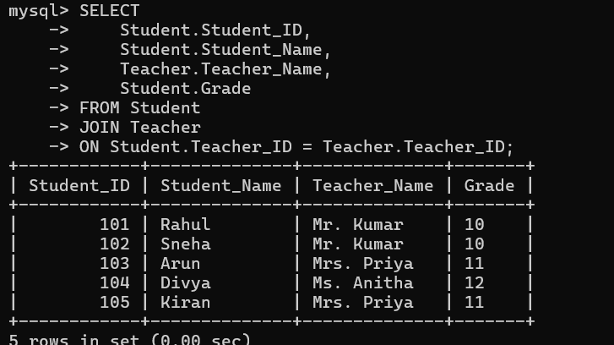
- A hospital wants to track patient appointments. Design the relational schema and write SQL to find doctors with more than 10 appointments this month.
Sol:
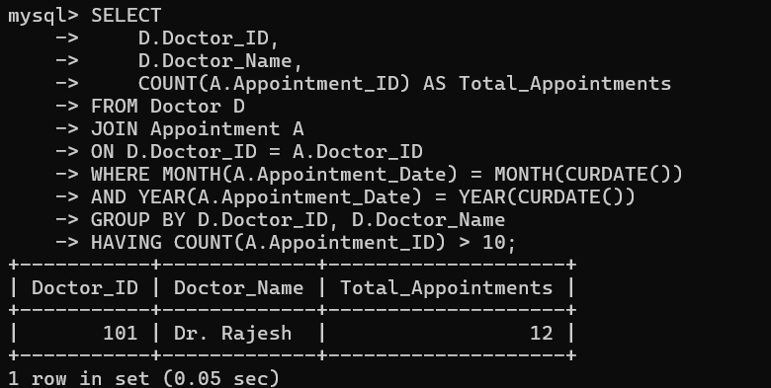
- In an e-commerce scenario, write SQL queries using sub-queries to find products that have never been ordered.
Sol:
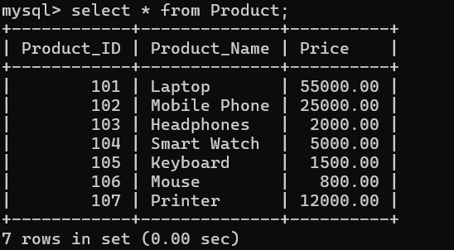
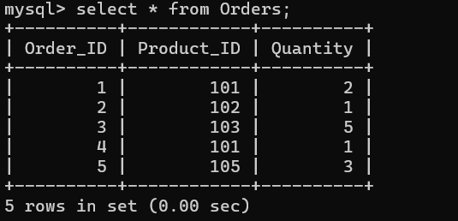

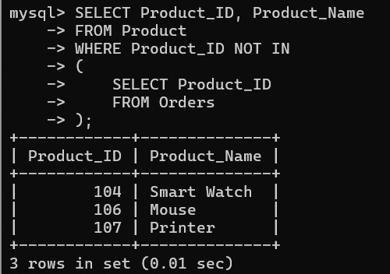

- University Database (Relational Algebra)
Relations:
- Student(Student_ID, Student_Name)
- Course(Course_ID, Course_Name)
- Enrollment(Student_ID, Course_ID)
RELATIONAL ALGEBRA:
πStudent_Name
(Student ⨝(πStudent_ID(σCourse_Name='DBMS'(Course)
⨝ Enrollment)∩πStudent_ID(σCourse_Name='OS'(Course)
⨝ Enrollment)))
- Given a payroll scenario, create a view showing employees whose salary is below department average and write a query to update their salary by 10%.
Sol:
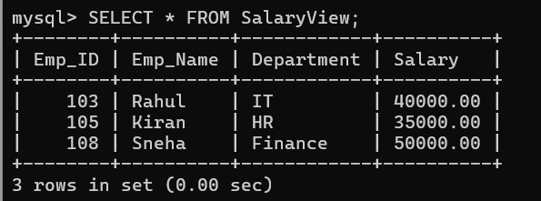
Update Salary by 10%:
UPDATE Employee
SET Salary=Salary*1.10
WHERE Salary<(SELECT AvgSalary FROM(SELECT Department, AVG(Salary) AS AvgSalary FROM Employee
GROUP BY Department) AS DeptAvg
WHERE DeptAvg.Department=Employee.Department);

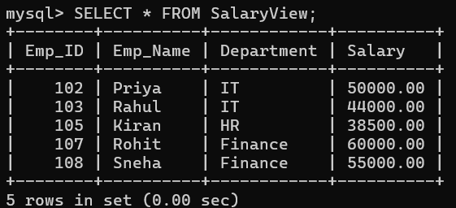
- In a banking scenario, apply JOIN operations to retrieve customer account details, transaction history, and branch information.
Sol:
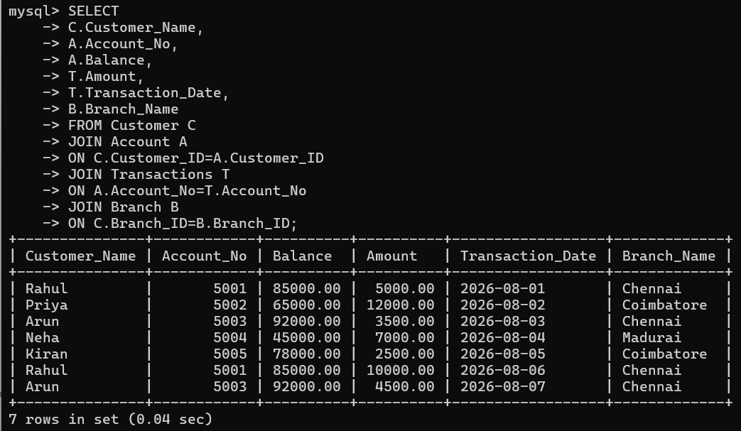

- A retail store needs daily sales summary. Write SQL with GROUP BY and HAVING to report total sales per category exceeding Rs.10,000.
Sol:
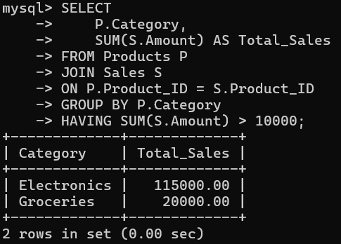
- For a library system scenario, construct tuple relational calculus expressions to find members who borrowed books from all genres.
Sol:
RELATIONS
Member : Member(Member_ID, Member_Name)
Book: Book(Book_ID, Book_Name, Genre)
Borrow: Borrow(Member_ID, Book_ID)
TUPLE RELATIONAL CALCULUS EXPRESSION:
{M.Member_Name |Member(M) ∧∀G (∃B (Book(B) ∧ B.Genre = G.Genre)→ ∃Br (Borrow(Br) ∧ Br.Member_ID = M.Member_ID ∧ Br.Book_ID = B.Book_ID))}
EQUIVALENT SQL QUERY:
SELECT m.Member_Name
FROM Member m
WHERE NOT EXISTS ( SELECT DISTINCT Genre
FROM Book
WHERE Genre NOT IN (SELECT b.Genre
FROM Borrow br
JOIN Book b
ON br.Book_ID = b.Book_ID
WHERE br.Member_ID = m.Member_ID));
- Given an inventory management scenario, define CHECK and FOREIGN KEY constraints and demonstrate their enforcement through SQL.
Sol: Demonstrating CHECK Constraint:
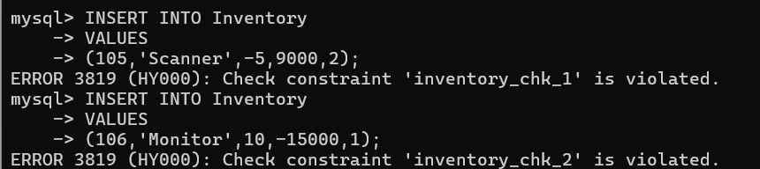
Demonstrating FOREIGN KEY Constraint:
- Design a relational schema for an HR system and create materialized views for monthly attendance and performance summaries.
Sol: Attendence summary view:
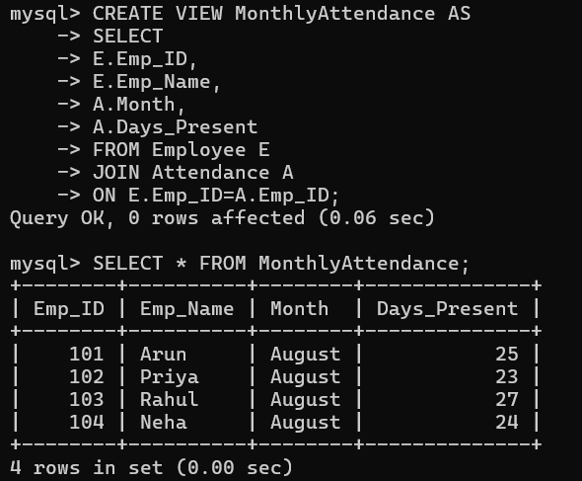
Performance summary view:
